Sarah Griggs - Sarahec227@gmail.com

September 22, 2018

**Method**

Data was extracted using SQL queries on city_data and global_data databases after first investigating the cities available for data extraction in city_list. These queries are available to be seen in the appendix as SQL Query 2, SQL Query 3, and SQL Query 1 respectively. Instructions were to pull data from the nearest city to you with available data. I live in Minneapolis proper and was able to query for Minneapolis data in the city_data database and thus created a comparison between Minneapolis weather trends and Global weather trends.

Once data was extracted into .csv format, it was opened using Microsoft Excel and saved into an Excel format. Data from the Query 2 and Query 3 were joined on date using an inner join. See appendix Spreadsheet 1.

Within Spreadsheet 1, 7-day and 14-day moving average functions were performed on each average temperature column (both global and Minneapolis average temperature) in order to smooth the trends. The excel function to calculate 7 day moving average is an average of the current and prior 6 day values, for a total of an average of 7 values. The excel function to calculate 14 day moving average is an average of the current and prior 13 day values, for a total of an average of 14 values. Please see appendix Spreadsheet 1 for visual.

Two line charts were created comparing the trends between Minneapolis average temperatures and global average temperatures using the 7-day moving averages and 14-day moving averages respectively. See appendix Chart 1 and Chart 2. Line charts were chosen to visualize the trends because the time series represented in the chart is long and temperature data is narrow. These line charts enable us to see the declining margin between the two trends as time progresses. Also included in the line charts are linear trend lines to create a simple mathematical comparison in growth rate between the two weather trends.

**Insights**

The Minneapolis average temperature and the global average temperature follow similar patterns, however the Minneapolis average temperature is much more volatile than the global average temperature. We can see this in Chart 1. We see the similarities in the overall upward trend of the charts with similar local maximums between 1771 and 1785 as well as similar local minimums between 1813 and 1827. We can see the volatility when we notice that the Minneapolis line shows many more local minimum and maximums in its pattern while maintaining the overall upward trends.

Between 1750 and 2013, the average Minneapolis temperature was 3.42 degrees, on average, lower than the average global temperature. Over time, the average temperature difference has narrowed. The first half of this time period, 1750-1882, the Minneapolis average temperature was, on average, 3.53 degrees lower than the average global temperature, while the second half of this time period 1882-2013 only showed a 3.31 degree average difference.

This narrowing in temperature difference indicates that Minneapolis has an average temperature that is increasing at a faster rate than the average global temperature. We can see this in the linear trend lines on Chart 1 and Chart 2. The trend lines on Chart 2, chosen for this comparison for further reduced volatility, show the average temperature in Minneapolis is growing approximately 29.5% (.0057/.0044) faster than the average global temperature.

While Minneapolis may have an average temperature that is growing at a more rapid rate than average global temperature, we can see from these same trend lines, on Chart 2, that both are growing in a positive direction, indicating an overall increase in temperature trend.

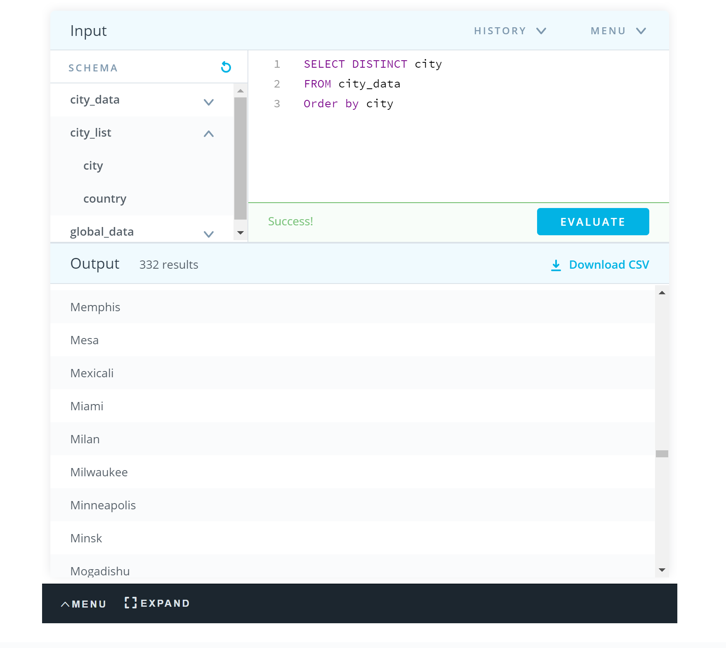**Appendix**:

SQL Query 1 – Pull city list to inspect data and find nearest city from city_data database

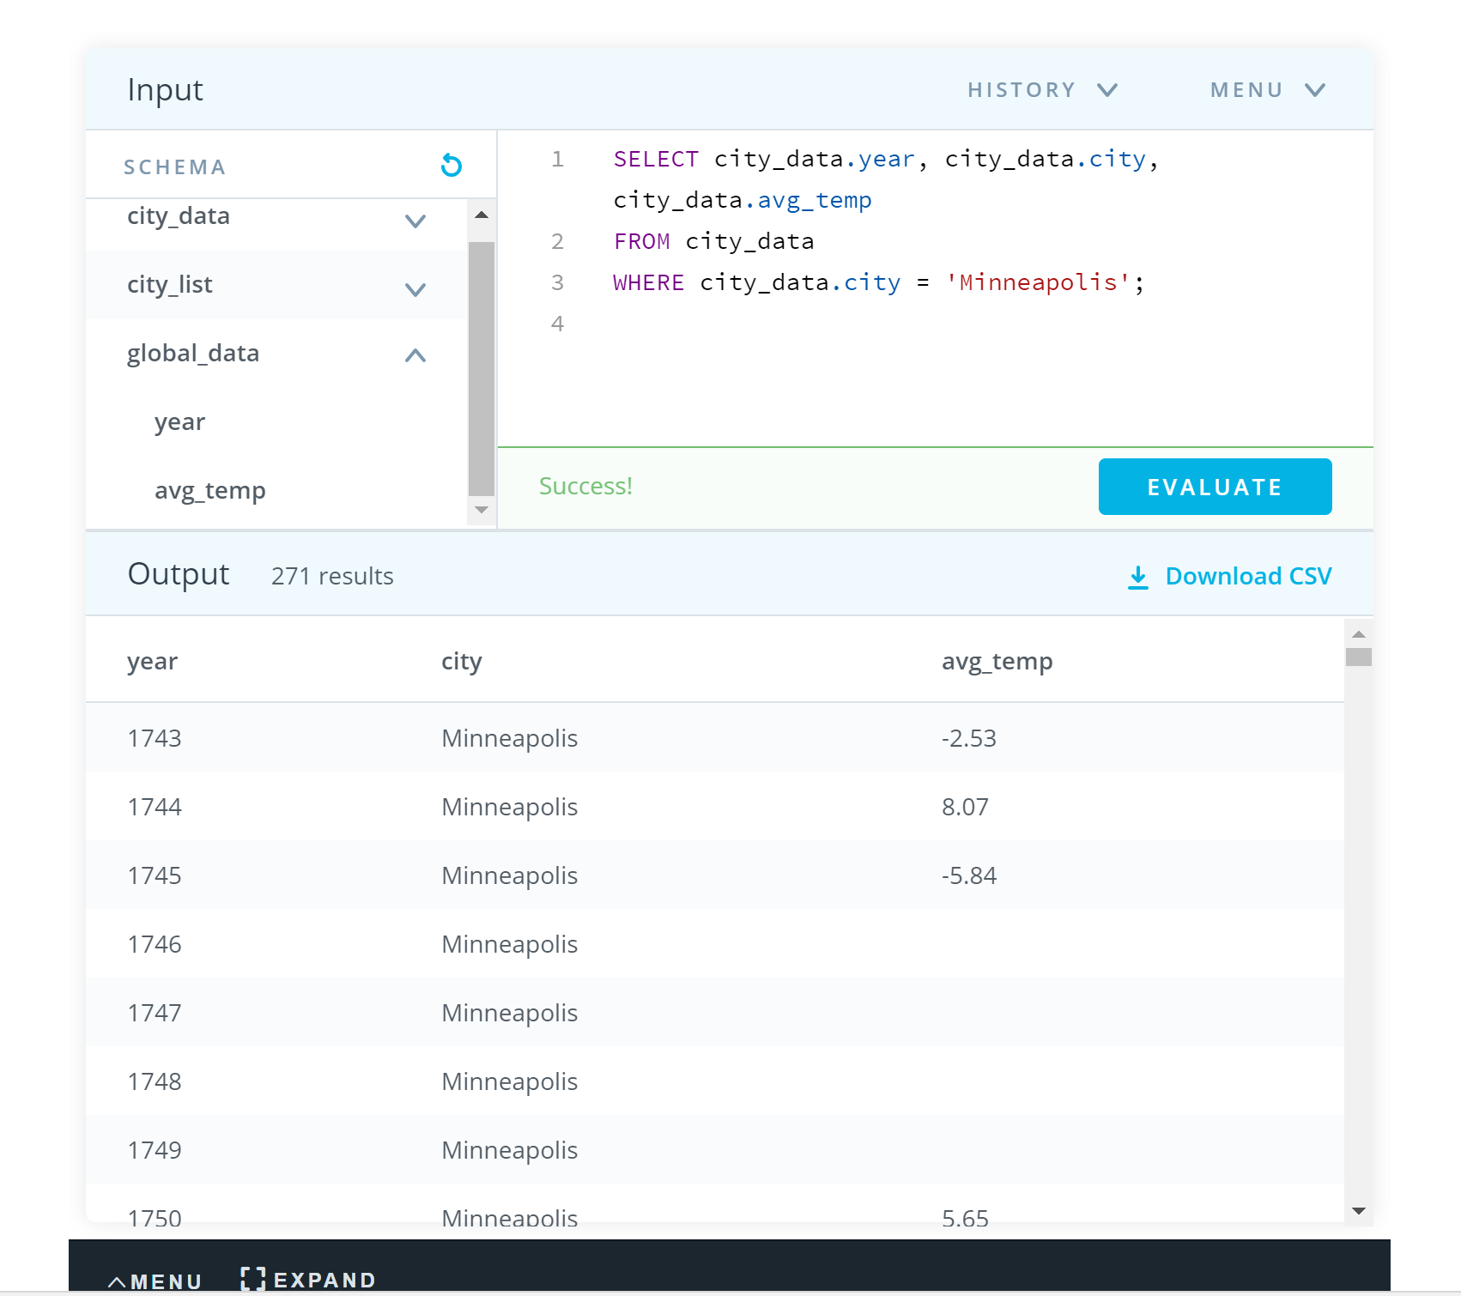

SQL Query 2 – pull Minneapolis data from city_data database

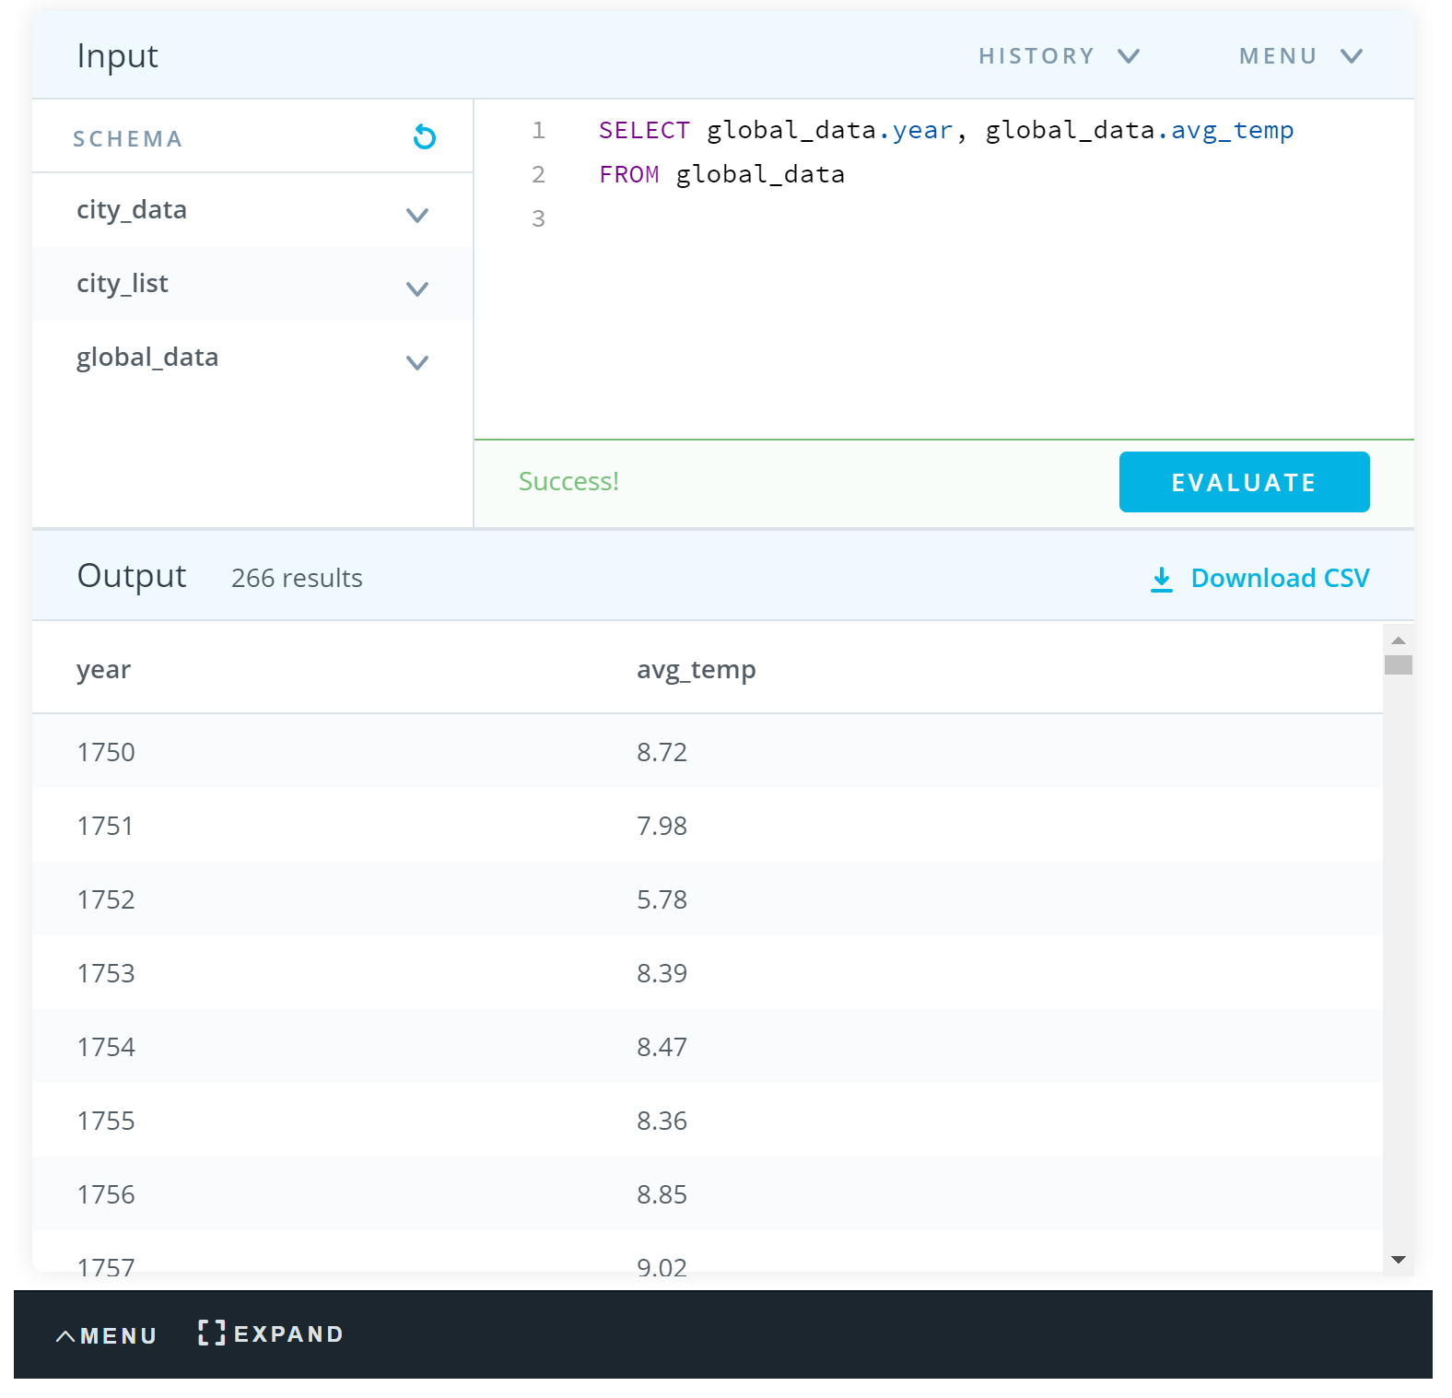SQL Query 3 – pull global weather data from global_data database

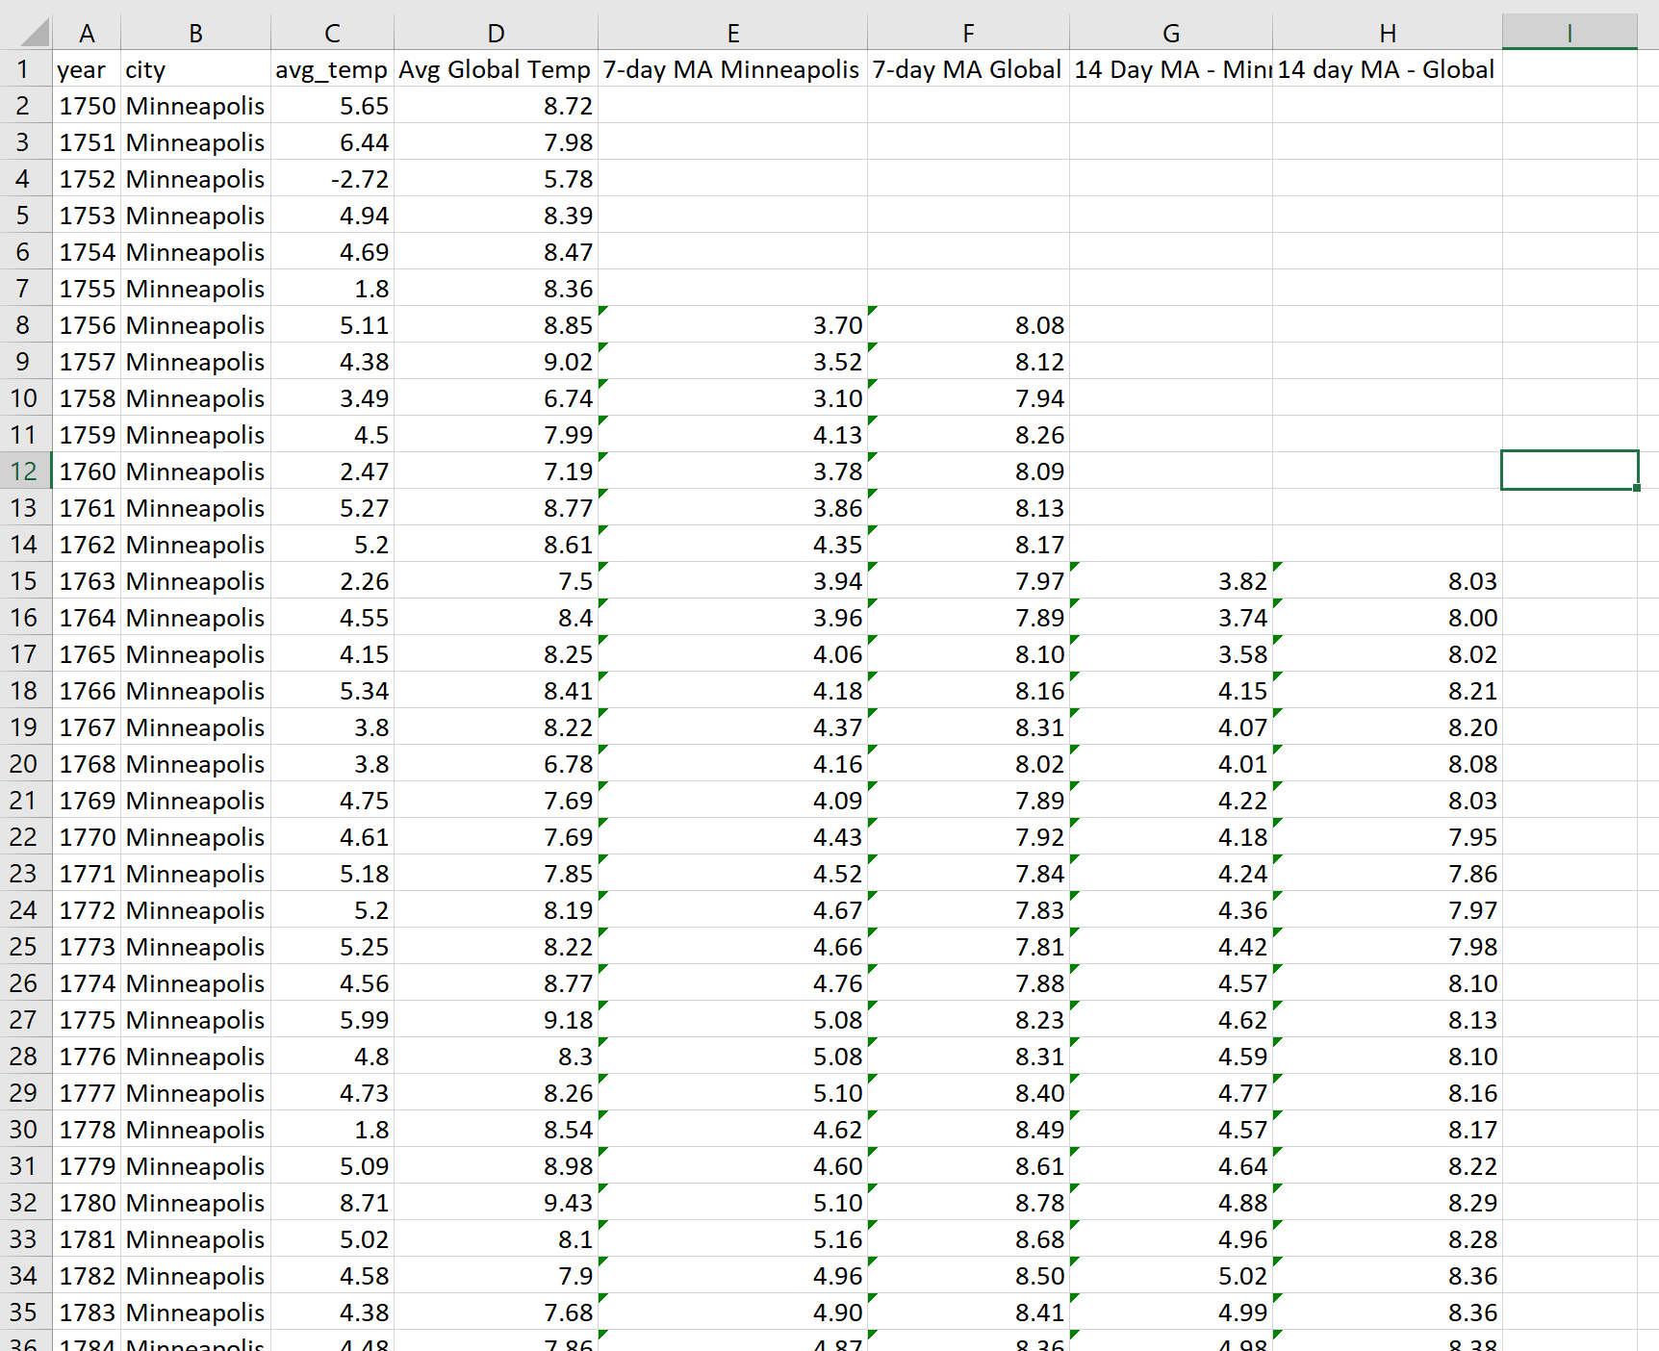

Spreadsheet 1 - joined global and temp data on year and calculated both 7-day MA for Minneapolis and 7-day MA for Global, as well as 14-day MA for Minneapolis and 14-day MA for Global

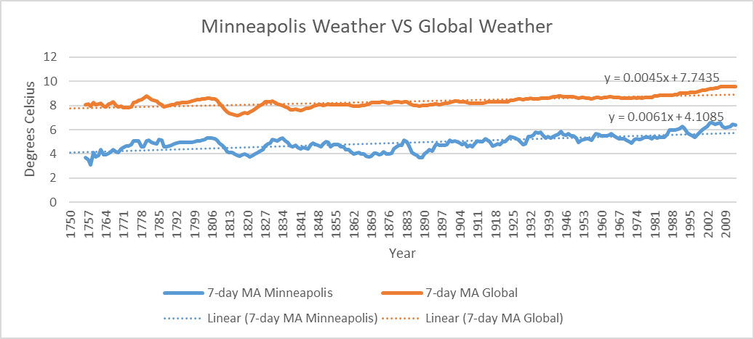

Chart 1 - 7-day MA chart with trend lines for further investigation

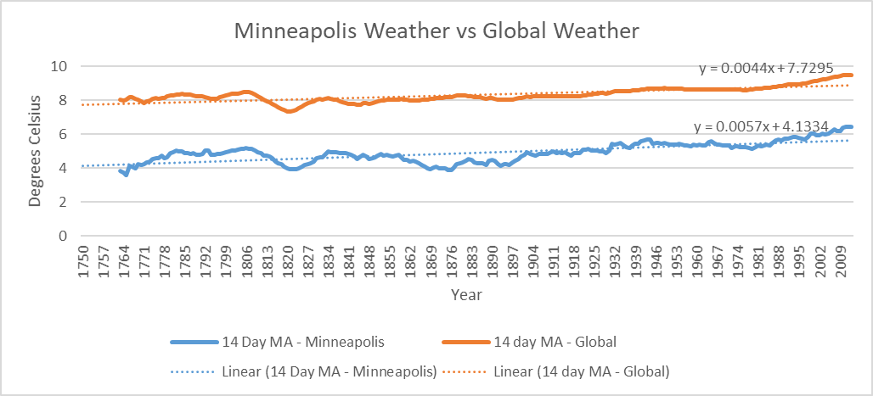

Chart 2 – 14-day MA chart with trend lines for further investigation